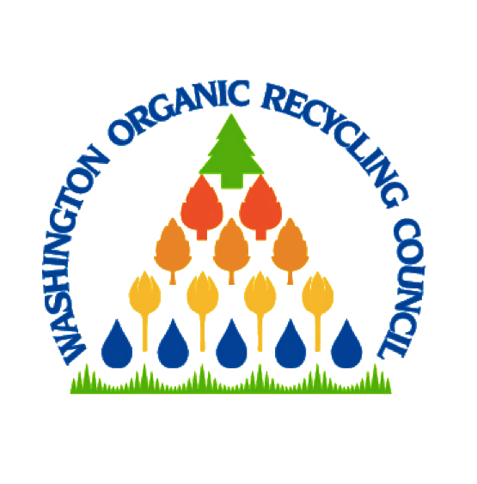 |  | WORC Annual Conference  “Full Circle Compost: From Sustainable to Regenerative”

Day 1

9:30 am-Registration

10:00 am-12:00 pm- ROT

12:00 pm-1:00 pm Lunch provided

1:00 pm-3:30 pm-Workshop Finian Makepeace

5:30 pm-7:30 pm Presidents Reception

Day 2

7:30 am-Registration

8:00 am Welcome and Breakfast Dan Corum

8:15 am-10:00 am- Keynote presentation Finian Makepeace

10:30 am- 11:30 am Panel Discussion 1

11:30 am-12:00 pm- Annual Meeting President Fleischner

12:00 pm-1:00 pm Lunch provided

1:00 pm-2:00 pm Panel Discussion 2

2:00 pm-2:15 pm Networking Break

2:15 pm-2:45 pm Title V Discussion Mary Harrington

2:45 pm-3:00 pm Closing Remarks President Fleischner

