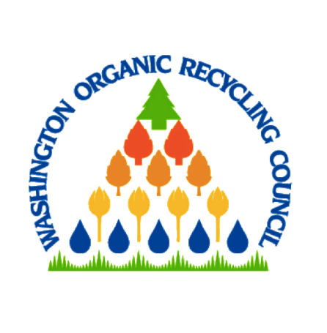
WASHINGTON ORGANIC RECYCLING COUNCIL
WORC Board Meeting
April 16th, 2020 MINUTES

Call to Order – President, Samantha Fleischner called the meeting to order at 10:10 am. Additional participants were, Vice President, Steve Diddy, Kaitlyn Treasurer, Scott Deathrage, Secretary, Welzen, Jack Hoeck, Mary Harrington, Jay Blazey, Patrick Jordan, David McDonald, Ashley Mihle, Dan Corum, and CEO Britni Lundin

Absent were, Nehemias Chalma & Stephanie Miller

Consent Agenda: Board accepted February 2020 minutes and February 2020 financial reports.

Financials: The Executive Director presented a sustainability report highlighting the WORC could operate into 2022 with no additional income. This places WORC in a healthy financial situation in the midst of the Pandemic.

Strategic Partnerships:
- ORIA- Contacted but unresponsive
- WRRA -Samantha working on it
- Tithe and NW Biosolids- Ashley reaching out
- Air Districts- Removed

Committee Reports:
Annual Conference: Conference has been cancelled due to competing dates with WSRA conference and the Pandemic causing venue contract securing to be limited. Ashley is following up with Tilth and NW Biosolids regarding 2021 event collaboration. Payment logistics will need to be considered moving forward.

CFOT: CFOT registration has been postponed due to the COVID-19 situation. WORC needs to ensure that they do not need to refund students therefore causing WORC to incur credit card processing fees. If WSU Puyallup is closed due to the Pandemic, then we will not be able to hold CFOT at their facility. The Committee continues to plan and is considering doing a pre-sign up page.

Membership, Outreach, Communications: Membership events are on hold in the hopes that appreciation events will be able to be held in person at Woodland Park Zoo. The event would most likely be held in conjunction with a Board meeting and would include a speaker, possible tour and off site happy hour.

ROT: ROT has been postponed as most Air Districts have declined attendance. There is discussion that there will be testing. This would be beneficial for WORC Members in the progression of this issue. ROT Committee will be doing an update for the upcoming newsletter. The Committee is considering providing a link for members to fund research. Committee needs better internal communication among committee members to ensure successful collaboration. Steve asks that all Committee information be sent to him directly to streamline communication.

Soils for Salmon: Website has been updated and is running! Final edits have been made, and David is working to update fact sheets in the next couple of weeks.

Legislative: Legislation that was passed in the last session has funding either cut or on hold due to the Pandemic. Both the Sustainable Agriculture and Compost Usage and Procurement bills passed. The Compost Usage and Procurement bill passed with a partial veto in addition to the request for a legal definition of “Compost”.
The Department of Ecology Food Waste Reduction Taskforce is still in effect, however partners are now working on emergency food response. It is anticipated that the taskforce will be back together in May.
There being no further business, the meeting was adjourned at 12:00 pm

